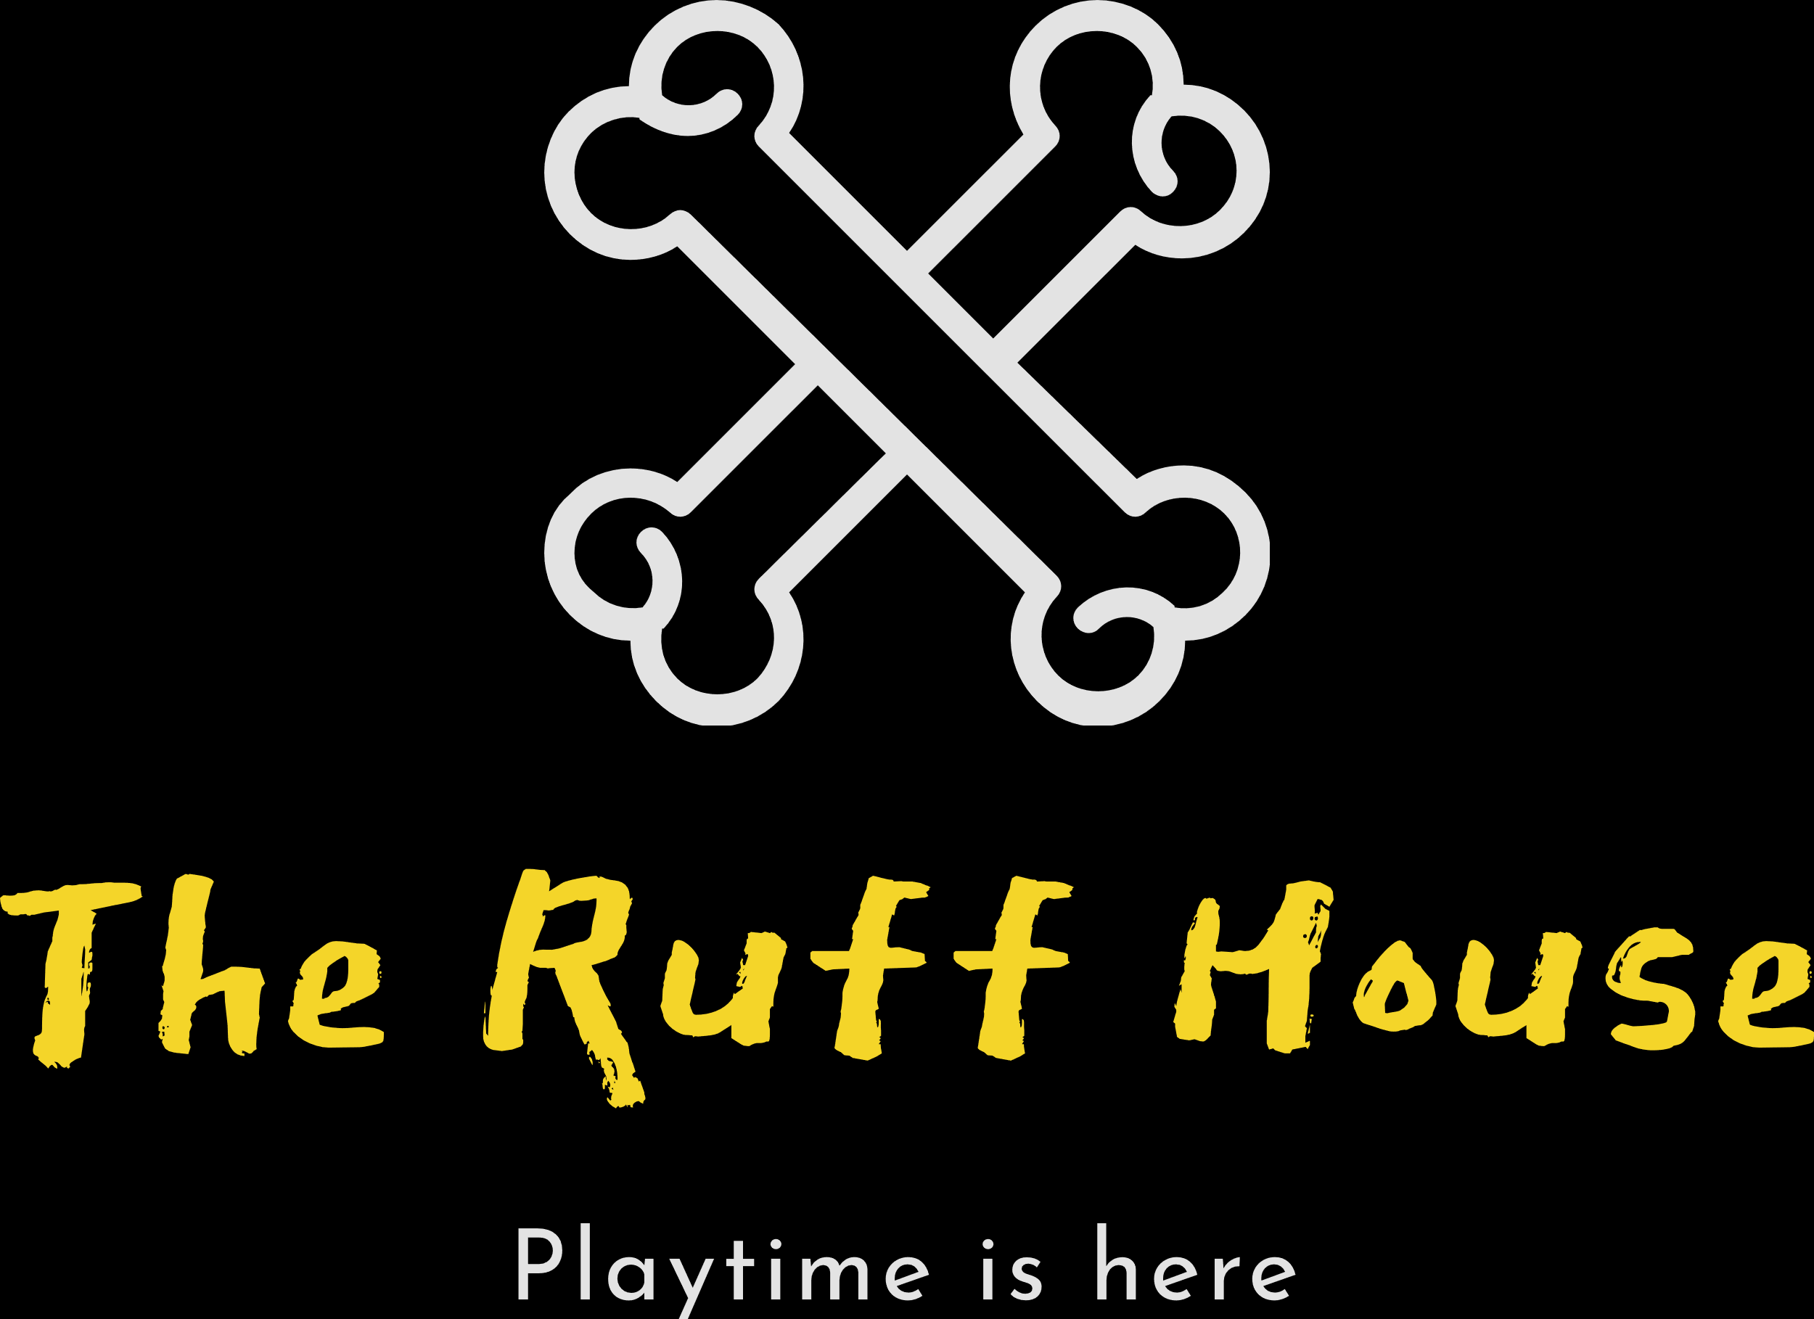

Waiver and Release Form
I understand that I am solely responsible for any harm caused to or by my dog(s) while my dog(s) is/are the care of The Ruff House. I also understand and agree that in admitting my dog(s), The Ruff House has relied upon my representation that my dog(s) is/are in good health and have not harmed, shown aggression or threatening behavior towards any person or animal at any time.
I further understand that due to the way dogs interact and play with one another, cuts, nips, illnesses and scratches can occur even though the dogs are supervised.
While my dog(s) is/are in the care of The Ruff House, if I am unreachable in the event of an emergency, I hereby authorize The Ruff House, its agents, employees and/or representatives to seek immediate veterinary care for my dog(s). I understand that all costs in connection with veterinary, medical or other treatment, shall be my sole responsibility.
I hereby release and agree to hold harmless The Ruff House, its owners, directors, officers, members, employees and agents from any and all liability, claims, suits, actions, loss, injury or damage of any nature or kind, or for any liability, claims, suits, actions, loss, injury or damage which I or my dog(s) may sustain or which may be caused in any way by my dog(s). I specifically, without limitation, agree to fully indemnify The Ruff House for any and all such liability, claims, suits, actions, losses, injury or damage. I specifically agree to indemnify and hold harmless The Ruff House as to any loss, cost, claim, injury, damage or liability, sustained or incurred which is caused by an act or omission, whether negligent, intentional or otherwise, of an employee, representative, or agent of The Ruff House.
I understand that if my dog(s) display aggressive, harmful or nuisance behaviors, for the safety of other dogs and the employees of The Ruff House, that my dog may be corrected and/or confined to a kennel until he/she can be picked up. The Ruff House reserves the right to permanently remove any dog at any time and refuse admittance to any dog(s) which do not meet the health and temperament requirements which include, but are not limited to inoculations for distemper, bordetella, rabies and flea and heartworm prevention.
I agree to pay all charges incurred by the services I or my dog(s) receives while in the care of The Ruff House. If I should not return for my dog, The Ruff House will make every attempt to contact me. If my dog is not picked up by close of business, a late fee will be assessed and/or my dog will be boarded overnight. If after 7 days of no contact from the owner, The Ruff House will consider the animal(s) abandoned and will re-home the animal.
I additionally give consent for my dog to be photographed while in the facilities at The Ruff House. I agree to give The Ruff House to use my dog’s image on promotional materials, which may include its website and Facebook fan pages.
I certify that I have made full disclosure and have read, understand and accept the terms, conditions and statements in this agreement. Furthermore I acknowledge that this agreement shall be effective and binding upon parties.

_________________________________________ _____________
Signature of Owner Date

